**AGGREGATE FUNCTIONS**

CREATE TABLE STUDENT_EXP07_CSA_41 (STUDENT_ID NUMBER PRIMARY KEY, STUDENT_NAME VARCHAR2(50), PHYSICS NUMBER(2), CHEMISTRY NUMBER(2), MATHEMATICS NUMBER(2));

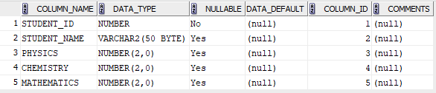

INSERT INTO STUDENT_EXP07_CSA_41 (STUDENT_ID, STUDENT_NAME, PHYSICS, CHEMISTRY, MATHEMATICS) VALUES (1, 'JOSE', 15, 18, 40);

INSERT INTO STUDENT_EXP07_CSA_41 (STUDENT_ID, STUDENT_NAME, PHYSICS, CHEMISTRY, MATHEMATICS) VALUES (2, 'PRANAV', 10, 12, 30);

INSERT INTO STUDENT_EXP07_CSA_41 (STUDENT_ID, STUDENT_NAME, PHYSICS, CHEMISTRY, MATHEMATICS) VALUES (3, 'JIBIN', 20, 25, 35);

INSERT INTO STUDENT_EXP07_CSA_41 (STUDENT_ID, STUDENT_NAME, PHYSICS, CHEMISTRY, MATHEMATICS) VALUES (4, 'ALWIN', 25, 20, 50);

INSERT INTO STUDENT_EXP07_CSA_41 (STUDENT_ID, STUDENT_NAME, PHYSICS, CHEMISTRY, MATHEMATICS) VALUES (5, 'ALTHAF', 12, 15, 20);

INSERT INTO STUDENT_EXP07_CSA_41 (STUDENT_ID, STUDENT_NAME, PHYSICS, CHEMISTRY, MATHEMATICS) VALUES (6, 'ASHHAR', 13, 22, 40);

INSERT INTO STUDENT_EXP07_CSA_41 (STUDENT_ID, STUDENT_NAME, PHYSICS, CHEMISTRY, MATHEMATICS) VALUES (7, 'NANDU', 18, 12, 45);

INSERT INTO STUDENT_EXP07_CSA_41 (STUDENT_ID, STUDENT_NAME, PHYSICS, CHEMISTRY, MATHEMATICS) VALUES (8, 'ASHWIN', 15, 14, 35);

INSERT INTO STUDENT_EXP07_CSA_41 (STUDENT_ID, STUDENT_NAME, PHYSICS, CHEMISTRY, MATHEMATICS) VALUES (9, 'AWIN', 17, 18, 28);

INSERT INTO STUDENT_EXP07_CSA_41 (STUDENT_ID, STUDENT_NAME, PHYSICS, CHEMISTRY, MATHEMATICS) VALUES (10, 'BASIL', 19, 23, 48);

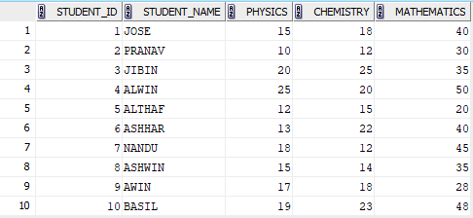

SELECT AVG(PHYSICS) AS CLASS_AVG_PHYSICS FROM STUDENT_EXP07_CSA_41 ;



SELECT MAX(MATHEMATICS) AS HIGHEST_MARKS_MATHS FROM STUDENT_EXP07_CSA_41 ;



SELECT MIN(CHEMISTRY) AS LOWEST_MARK_CHEMISTRY FROM STUDENT_EXP07_CSA_41 ;



SELECT COUNT(*) FROM STUDENT_EXP07_CSA_41 WHERE PHYSICS >= 12;



SELECT STUDENT_NAME FROM STUDENT_EXP07_CSA_41 WHERE PHYSICS >= 12 AND CHEMISTRY >= 12 AND MATHEMATICS >= 25;

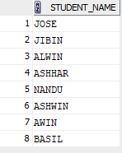

SELECT STUDENT_NAME , PHYSICS + CHEMISTRY + MATHEMATICS AS TOTAL_MARKS, CASE WHEN PHYSICS >= 12 AND CHEMISTRY >= 12 AND MATHEMATICS >= 25 THEN 'PASS' ELSE 'FAIL' END AS STATUS FROM STUDENT_EXP07_CSA_41 ORDER BY TOTAL_MARKS DESC;

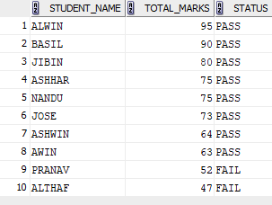

SELECT (COUNT(CASE WHEN MATHEMATICS >= 25 THEN 1 END) * 100 / COUNT(*)) AS PASS_PERCENTAGE_MATHS FROM STUDENT_EXP07_CSA_41;



SELECT (COUNT(CASE WHEN PHYSICS >= 12 AND CHEMISTRY >= 12 AND MATHEMATICS >= 25 THEN 1 END) * 100 / COUNT(*)) AS OVERALL_PASS_PERCENTAGE FROM STUDENT_EXP07_CSA_41;



SELECT AVG(PHYSICS + CHEMISTRY + MATHEMATICS) AS CLASS_AVERAGE FROM STUDENT_EXP07_CSA_41 ;



SELECT COUNT(*) FROM STUDENT_EXP07_CSA_41 WHERE PHYSICS >= 12 AND CHEMISTRY >= 12 AND MATHEMATICS >= 25;

